NOTICE OF STUDY COMMENCEMENT/
Burloak Water Purification Plant Phase 2,
Town of Oakville
Municipal Class Environmental Assessment Study

Background
Halton Region is initiating a Class Environmental Assessment (Class EA) Study to increase the capacity of the Burloak Water Purification Plant (WPP). A review of the Region’s Water and Wastewater Servicing Master Plan, completed in 2004, identified the need for the new Burloak WPP to meet the demands of future development.

Problem Statement
The 2004 Master Plan Review recommended that the Burloak WPP be constructed in phases to satisfy the water supply needs for the projected population. The Burloak WPP has a current capacity of 55,000 m³/day. An update to the Master Plan completed in 2008 identified that the next phase of expansion of the Burloak WPP is to a treatment capacity of 165,000 m³/day.

The Process
The Class EA study is being conducted according to the requirements of a Schedule “C” project of the Municipal Class Environmental Assessment document (October 2000, amended in 2007). The purpose of the Class EA study is to identify the preferred solution for increasing water treatment capacity at the plant. The study will include:
- public and agency consultation
The map below covers the approximate limits of the study area
- evaluation of alternative design concepts for the expansion
- 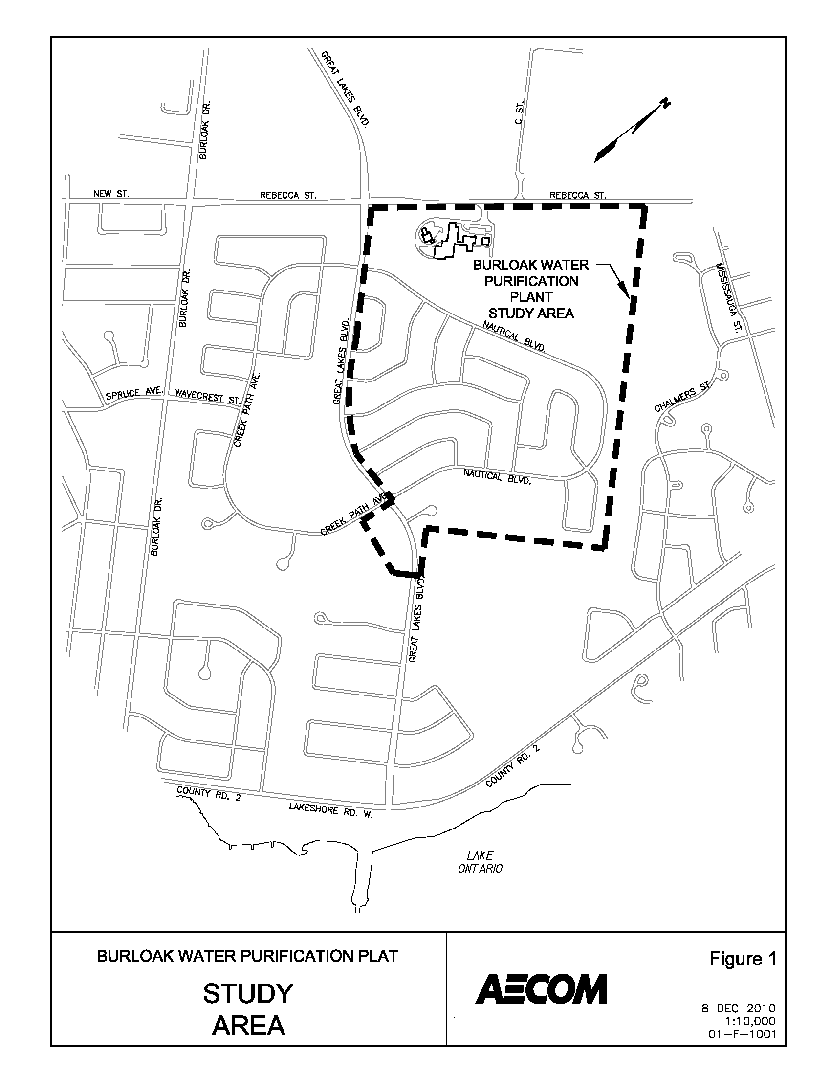assessment of the impacts of the proposed work
- identification of measures to mitigate potential impacts
- consideration of technical, socio-cultural, natural environmental and economic issues.

Public Information Centers
We will consult with the public and review agencies throughout the Class EA process. Two Public Information Centres (PICs) will be held in association with this study. We will publish invitation notices to the PICs in local newspapers, on the Region’s website and distribute to all individuals who express an interest in this project.

Contact Us
Please contact either one of the following project team members if you have any questions or comments related to the study, wish to obtain more information on the study or wish to be added to the study mailing list:

Kelly Goorts  Regional Municipality of Halton  Telephone: 905-825-6000 ext.3309  Fax: 905-825-8822  kelly.goorts@halton.ca | Oya Koc  AECOM  5600 Cancross Court, Suite A  Mississauga, Ontario, L5R 3E9  Telephone: 905-712-6998  Fax: 905-501-0181  Oya.koc@aecom.com
Additional information related to the study and consultation process may be obtained through the study website:
http://www.halton.ca/WaterWastewaterClassEAs
First Issued Feb 3/11

PUBLIC INFORMATION CENTRE NO. 3
Burlington/Oakville Interconnecting Watermain – Zone 1
Municipal Class Environmental Assessment Study
Background
Halton Region recently completed the 2008 South Halton Water and Wastewater Master Plan Update. This Master Plan Update identified several infrastructure projects which are required to service growth in the approved urban areas of Burlington, Oakville, Milton and the Halton Hills 401 Corridor to the year 2021, including a watermain that will supply water to the Kitchen Reservoir from the Burloak Water Purification Plant (refer to map). This watermain will interconnect Zone 1 in Burlington with Zone 1 in Oakville and therefore will require a crossing of Bronte Creek.

Problem Statement
To identify a preferred alignment and construction method for the proposed Zone 1 watermain that will facilitate water conveyance from the Burloak Water Purification Plant to the Kitchen Reservoir and, thereby, provide additional water capacity for approved growth areas and also improve security of water supply to North Oakville and Milton.

The Process
As a part of the study, Public Information Centres (PICs) have been held to present the alternative routes that were being evaluated for the proposed watermain (PIC No. 1 - March 26, 2009) and preliminary preferred route (Bronte Road alignment), associated impacts and proposed mitigation measures (PIC No. 2 - June 18, 2009).

Upon further evaluation, public comment and agency review, a different preferred watermain route (Burloak Drive alignment) has been recommended. This alternative will be presented at a third PIC scheduled for:

Public Information Centre Location:

Municipality | Date | Time | Location
Town of Oakville,  City of Burlington | Thursday,  February 24, 2011 | 6:00 - 8:00pm | Halton Regional Centre  1151 Bronte Road  (Glenorchy-Dakota Room)

The PIC will be a drop-in format and provide residents/interested parties with an opportunity to review and comment on the recommended preferred alternative. Representatives from the Region and its consultants will be present at the PIC to answer questions and discuss the next steps in the study.

You are encouraged to attend the PIC and provide your comments so that they may be included in the study. Comments received through the course of the study will be considered in finalizing the recommended watermain alignment as well as construction mitigation measures. Comments and information regarding this project are being collected to assist the project team in meeting the requirements of the Class EA process. With the exception of personal information, all comments will become part of the public record.

Please contact either one of the following project team members if you have any questions or comments, wish to obtain more information on the project, or if you would like to be added to the mailing list:

David Simpson  Water Planning, Public Works  Regional Municipality of Halton  Tel: 905-825-6000 ext. 7601  Fax: 905-825-8822  E-mail: david.simpson@halton.ca | Ken Collicott  R.V. Anderson Associates Limited  2001 Sheppard Avenue East, Suite #400  Toronto, Ontario  M2J 4Z8  Tel: 416-497-8600 ext. 294  Fax: 416-497-0342  E-mail: kcollicott@rvanderson.com

Additional information related to the study and consultation process may be obtained through the study website:
http://www.halton.ca/WaterWastewaterClassEAs
This Notice first issued on February 10, 2011.

NOTICE OF STUDY COMPLETION
CLASS ENVIRONMENTAL ASSESSMENT STUDY
Campbellville Well House Expansion
30 Glenda Jane Drive,
Campbellville, Town of Milton
PR-2484A

Background
Halton Region has completed a Class Environmental Assessment (EA) Study for the Expansion of the Campbellville Well House. This study’s goal was to consider alternative solutions for the expansion of the Campbellville Well House. The study also assesses the environmental impacts these solutions would have on the surroundings and which solution best solves the problems at hand.

The Process
The study has been completed in accordance with the approval requirements for Schedule ‘B’ projects as defined in the October 2000 Municipal Class EA document (as amended in 2007). The Class EA process for this project included public and agency consultation, an evaluation of alternatives, an assessment of the impacts of the proposed project and identification of the measures to prevent or mitigate impacts. A pre-design report was also completed in conjunction with the Class EA which includes more detailed analysis of specific portions of the project.

Preferred Solution
Based upon input received at the Public Information Centre, as well as input from review agencies and other key stakeholders, the Region and its Consultants have prepared the Project File for this project. The study identifies a permanent indoor standby generator and building addition as the preferred alternative. The design of the addition was made with the goal of minimizing the environmental impact to the surroundings and blending in with the neighborhood.
Project File
The Campbellville Well House Expansion Environmental Assessment study is available for viewing from September 30, 2010 to November 1, 2010 at the following locations and time:
Region Municipality of Halton  Citizen’s Reference Library  1151 Bronte Road  Oakville, ON L6M 3L1  Monday to Friday:  8:30 a.m. to 4:30 p.m. | Milton Public Library (Main Branch)  45 Bruce Street  Milton, ON, L9T 2L5  Tuesday - Thursday: 10 a.m. – 9 p.m.  Friday – Saturday: 10 a.m. – 5 p.m.  Sunday: 1 p.m. – 5 p.m.  Monday: Closed | Town of Milton  Clerk’s Department  150 Mary Street  Milton, ON, L9T 6Z5  Monday- Friday:  8:30 a.m. to 4:30 p.m.

Comments
If there are concerns regarding this Class EA study that cannot be resolved through discussion with the Regional Municipality of Halton, a person or party may request that the Minister of the Environment (see contact information below) make an order for the project to comply with Part II of the Environmental Assessment Act. This request (referred to as a Part II Order) must be received by the Minister at the address listed below, and copied to Suzanne Boyd at the Region of Halton, by November 1, 2010. If no request is received by 4:30 p.m. on November 1, 2010, the Region will proceed with the detailed design and construction of the project.

Minister of the Environment
135 St. Clair Avenue West, 12th Floor
Toronto, Ontario, M4V 1P5

For further information on this project, please contact:
Ms. Suzanne Boyd, P.Eng.  Project Manager  Halton Region  Wastewater Design and Construction  Telephone: 905-825-6000, Ext. 7151  Facsimile: 905-825-0267  E-mail: suzanne.boyd@halton.ca | Robert Poisson, P.Eng.  Project Manager  R.E. Poisson Engineering Inc.  55 Cork Street, East, Suite 200  Guelph, ON N1H 2W7  Telephone: 905-847-2002  Facsimile: (519) 767-2040  Email: robert@repoisson.com
This Notice first issued September 30, 201

